**JFK courier delivery process**

**Ⅰ、Company Profile:**

JFK Express Delivery System is a unified online management system customized by JFK Technology for enterprises, industrial park management offices, community property management offices, etc. It provides a common delivery solution of cabinet plus point plus person to solve single delivery. The high labor cost of collection management.

**Describe the issues (the problem, pain points that the company is facing)：**

**1、Current State Process**

JFK Technology Company invented the delivery cabinet, and they built the delivery cabinet and remote control system by themselves. Registered delivery personnel use the delivery counter for free during the promotion period. Due to lack of resources, only the mobile platform can be used to send SMS notifications to customers.

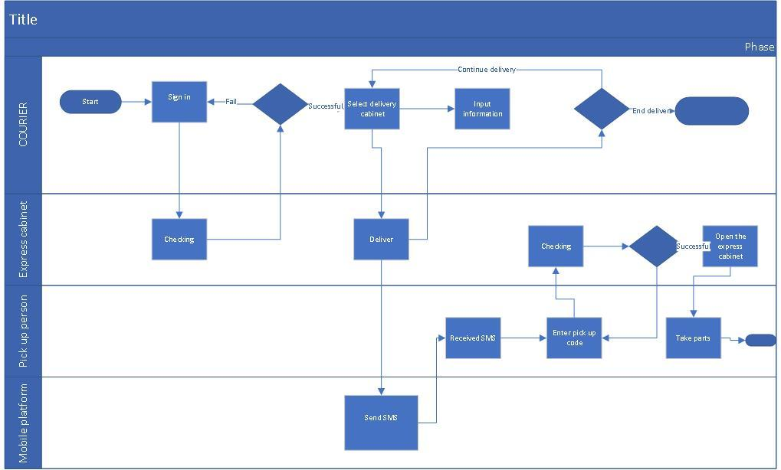

**2、Pain Points and Enablers**

With the promotion of the product, company JFK reached an agreement with major express delivery companies. Company JFK has added a QR code scanning device to the courier cabinet. Couriers of company delivery can not only log in on the courier cabinet (authentication service provided by company delivery), but also scan the courier number, and send text messages to company delivery automatically after delivery to the cabinet To customers. After the customer picks up the package, it will be automatically sent to delivery company for delivery.

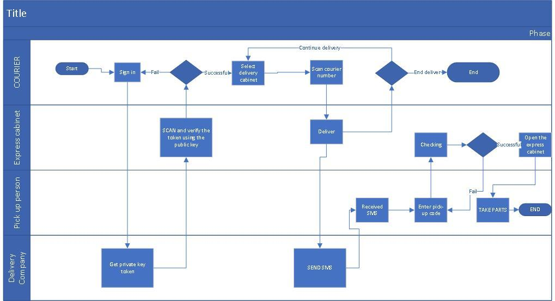

**3、Future State Process**

Company JFKfurther optimized its services and developed a WeChat applet to scan QR codes to get express delivery. If the user has followed the company's official account, he will directly push the user's pickup code and other information through the official account. No more text messages

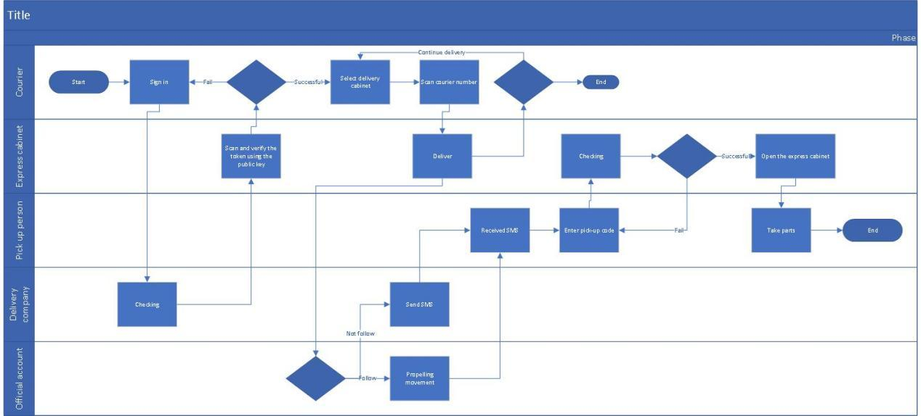

**Future State Process Benefits：**

**Perfect fusion of multiple functions**

1. **For consumers and users**

Multi-channel, diversified express delivery

Multiple payment methods

**2、For express service station (express cabinet)**

Unified and precise management

Online payment

Order printing

Accurate and clear reconciliation and settlement

**3、For courier system**

Hardware support and stable operation

**Ⅱ、**JFKdetailed **description of business rules and user requirements**

Company JFK has many delivery storage cabinets, and they need to record number, address, founding time of every cabinet. There are many storage rooms in a delivery cabinet, which are provided to the deliveryman to store items. Each storage room has its own number, and the company needs to record the usage. When the item is shipped, company JFK needs to mark that the storage room has been used, the time the items were stored, the information of the deliveryman, and the information of the person who picked up the item. Company JFK has a cooperative relationship with many delivery companies. Each delivery company has its own deliveryman. When a customer places an order with the delivery company, the delivery company appoints a deliveryman to drop the customer’s items into the storage room of the delivery cabinet. After delivery, company JFK generates a pickup code for the item and sends it to the customer through the official account. If the customer information is not found in JFK’s official account, the delivery company needs to send it to the pickup person via SMS.

**Ⅲ、An enhanced entity relation diagram**

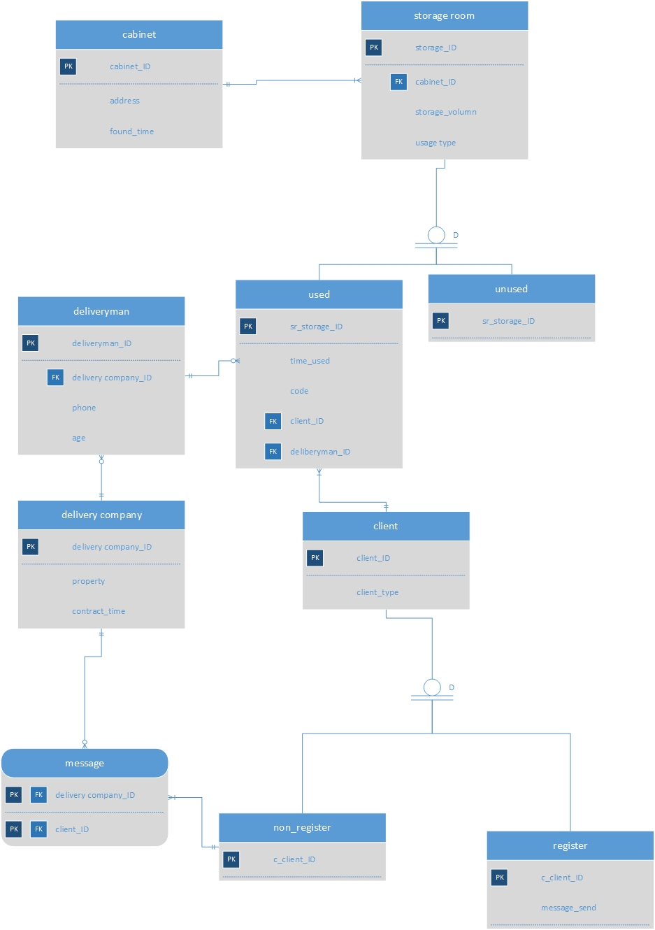

**Ⅳ、dictionary**

**Cabinet:**

**It includes the information about the delivery storage cabinet.**

|  |  |  |
| --- | --- | --- |
| **attribute** | **description** | **datatype** |
| **cabinet_ID** | **like cab001, record the unique id of every cabinet** | **varchar(5)** |
| **address** | **the detail location include city and street** | **varchar(20)** |
| **found_time** | **09/02/2020, time the cabinet founded** | **date** |

**storage room:**

**It includes the information for every cabinet.**

|  |  |  |
| --- | --- | --- |
| **attribute** | **description** | **datatype** |
| **storage_ID** | **record the unique id of every storage room** | **varchar(5)** |
| **cabinet_ID** | **cabinet belonged** | **varchar(20)** |
| **storage_volumn** | **cubic centimeter** | **int(2)** |
| **usage_type** | **if the room is used** | **char(1)** |

**used:**

**subtype of the entity storage room, if the usage_type is U**

|  |  |  |
| --- | --- | --- |
| **attribute** | **description** | **datatype** |
| **sr_storage_ID** | **record the unique id of every storage room** | **varchar(5)** |
| **time_used** | **time when item put into the room** | **date** |
| **code** | **the password to open the room** | **int(6)** |
| **client_ID** | **the number to identify a client** | **int(8)** |
| **deliveryman_ID** | **the number to identify a delivery man** | **int(8)** |

**unused:**

**subtype of the entity storage room, if the usage_type is N**

**deliveryman:**

**the information about the worker in the delivery company.**

|  |  |  |
| --- | --- | --- |
| **attribute** | **description** | **datatype** |
| **deliveryman_ID** | **to identify a worker** | **int(8)** |
| **deliverycompany_ID** | **to identify a company** | **int(5)** |
| **phone** | **phone number of the worker** | **char(10)** |
| **age** | **age of the worker** | **int(2)** |

**client:**

**the information about the customer of the delivery company.**

|  |  |  |
| --- | --- | --- |
| **attribute** | **description** | **datatype** |
| **client_ID** | **to identify a customer** | **int(8)** |
| **client_type** | **record if the customer register an account** | **char(1)** |

**non_register:**

**information about the customer who has not registered**

|  |  |  |
| --- | --- | --- |
| **attribute** | **description** | **datatype** |
| **c_client_ID** | **to identify a customer** | **int(8)** |

**register:**

**information about the customer who has registered**

|  |  |  |
| --- | --- | --- |
| **attribute** | **description** | **datatype** |
| **c_client_ID** | **to identify a customer** | **int(8)** |
| **message_send** | **if company successfully send code** | **char(1)** |

**message:**

**associative entity between delivery company and non_register. The delivery needs to send a message to the customer who has not registered.**

|  |  |  |
| --- | --- | --- |
| **attribute** | **description** | **datatype** |
| **c_client_ID** | **to identify a customer** | **int(8)** |
| **message_send** | **to identify a company** | **int(5)** |